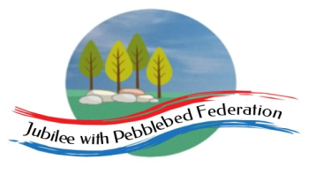 Home Learning Grid 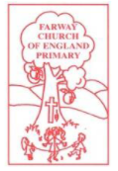
This is the home learning grid for the week beginning 8th March 2021. Please use this as a grid to support planning your child’s home learning. Additional resources will be made available on ‘google classrooms’, to support your child to access these activities. A daily reading and counting task are important to support your child to access their education but remember to have fun!
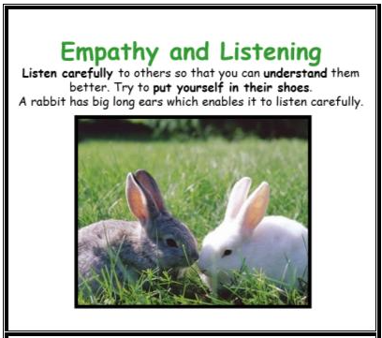
This week, all children will be returning to school after long periods at home, unless you are self-isolating. Therefore, Class 1 will be focusing on the key Learning Behaviour: Empathy and Listening. It is highly likely that most children, despite feeling excited and enthusiastic about their return to see friends, they will also be experiencing levels of anxiety, worry and anticipation about returning to school. If you are at home and not able to return, this may cause you to experience a range of emotions. It is important for you to remember that we are all in this together! We have all experienced our own journeys throughout this period, so we must take time to listen to how others are feeling to be able to better understand and help each other. Remember to have fun with your learning and that any concerns or celebrations please do contact Mrs Jackson.

If you have internet issues during this lockdown period, you can still access Google Classrooms using your phones. You can also contact the school and we can try and support you with alternative learning options.

 | Farway C of E Primary School - Class 1 – week beginning 8th March
 | Lesson 1 | Lesson 2 | Break time | Lesson 3 | Lesson 4
Monday  Please read for at least 10 minutes every day with an adult or a sibling.  You can use the Bug Club online books to access books in line with your child’s phonics ability. | Phonics - https://www.activelearnprimary.co.uk/login?e=-1&c=0#bugclub_phonics  Reception –  Recap Phase 3 sounds  Year 1  Recap Phase 5 sounds  Year 2  Recap phase 5 and 6 sounds | Juda’s betrayal / Last Supper  Show the children an image of a pile of money and an image of Love, family, friendship. Ask the children: which one do you feel is more important? Discuss children’s ideas and opinions?  Give children a selection of cards (money can buy/money can’t buy) – ask children to sort them into correct categories. Which pile is more important to you? Are there some items that humans need money for, to survive? (Links to PSHE)  Read the children the story of Judas’ Betrayal. Luke 22:1-6 (Miles Kelly page 437)  Ask children: do you feel you have ever betrayed a friend or loved one? Why do they think Judas betrayed Jesus to the Jewish officials?  Show children the artwork of ‘The Last Supper’, by Leonardo da Vinci.  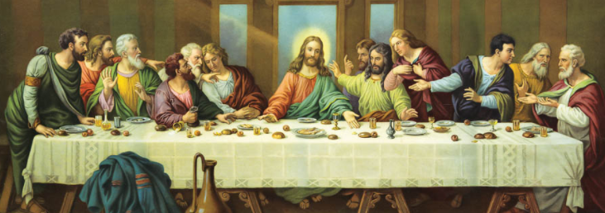  Ask the children: why do you think the last supper was so important to Jesus to share with his disciples?  Discuss with the children what special meals they share with their famiy? Why do they think their family insist on these meals? Do they sit up at the table together to eat? Or infront of tele at separate times?  Children to sit in a circle and have a little bit of bread to taste and a sip of grape juice. Whilst children are eating their bread and drinking their grape juice, teach the children the story of the last supper: page 440 (Miles Kelly) – Luke 22:7-53  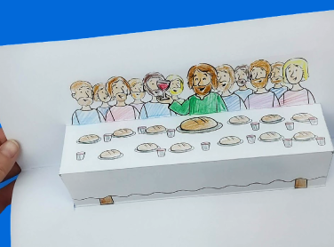  Children to create the Last Supper craft – pop up page.  Year 1 / 2 – write the words of Jesus: Jesus took the bread and said, ‘This is my body’… (year 2 using speech punctuation) | Make sure you take time to have a brain break today and stretch your bodies. Why not go for a walk around your garden or local area. Take in the signs of spring.  Alternatively, have a look through the mindfulness colouring sheets (found on google classroom) – make sure you take a break from the screen and enjoy being you! | Maths  Reception  WALT: explore length and measure  Home Learning - Early Years | White Rose Maths | Starting with a Story – hungry caterpillar  Year 1  WALT: compare length and height  Home Learning - Year 1 | White Rose Maths | Maths Lessons Online - lesson 1  Year 2  WALT: compare lengths  Home Learning - Year 2 | White Rose Maths | Maths Lessons Online – lesson 1 | Holistic Wellbeing  Spring is arriving and the sunshine has come out, finally! Take some time this afternoon to do an hours exercise of your choice. Go for a run, go cycling or even skip around your garden. Listen to the sounds around you and feel the sun on your face.  Spending time outdoors, in nature, exercising and doing something you enjoy, are fabulous ways to help stay healthy in both your mind and your body.  Have a look at the ten a-day to balancing mental health and think about the different ways you can help keep happy and healthy.  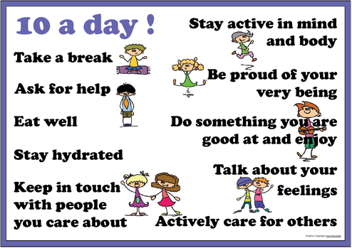
Tuesday  Please read for at least 10 minutes every day with an adult or a sibling. | Phonics - https://www.activelearnprimary.co.uk/login?e=-1&c=0#bugclub_phonics  Reception –  Recap Phase 3 sounds  Year 1  Recap Phase 5 sounds  Year 2  Recap phase 5 and 6 sounds | Literacy  WALT: box up our ideas and plan our writing.  As a class box up the ideas of the Woolly Mammoth text, using the grid. Orally rehearsing the story of the Woolly Mammoth, before typing up in the correct boxes.  As a class discuss instructions for ‘how to wash a hairy orangutan.’  What problems do you think there will be about how to get him in the bath?  Show children film clip of the animal playing: https://www.wwf.org.uk/learn/wildlife/orangutans  How might we get the orangutan into the bath? Widget their ideas as they generate them (for tomorrows write up)  What might the problems be? (hanging upside down, Tickly arms, Long, dangly limbs)  Think of some funny ways to encourage it into the water. What might you need to warn your reader about?  As a class fill in the boxing-up grid to generate ideas for the shared write. | Make sure you take time to have a brain break today and stretch your bodies. Why not go for a walk around your garden or local area. Take in the signs of spring.  Alternatively, have a look through the mindfulness colouring sheets (found on google classroom) – make sure you take a break from the screen and enjoy being you! | Maths  Reception  WALT: explore length and measure  Home Learning - Early Years | White Rose Maths | Starting with a Story – hungry caterpillar  Year 1  WALT: measure length (1)  Home Learning - Year 1 | White Rose Maths | Maths Lessons Online - lesson 2  Year 2  WALT: order lengths  Home Learning - Year 2 | White Rose Maths | Maths Lessons Online – lesson 2 | Mental Wellbeing  Colour Monster  https://www.youtube.com/watch?v=Ih0iu80u04Y  Read the story of the Colour Monster to the children.  What do they notice about the monsters?  What do they notice about the colours and the emotions?  How are you feeling today? If you were a colour monster, what colour would you be?  Children to draw and colour or paint their own colour monster to show how they are feeling (or can use template)  Year 1 to write a sentence to say how you are feeling?  Year 2 to write a sentence to say how you are feeling… use a conjunction to add extra information.  Reception – use phonics knowledge to write a caption for how they are feeling, ie: sad – if they can write a sentence then encourage this!  When chn have completed this task: Ask chn: do you think we will find any of these colours outside? Do you think we might find any other colours? Which ones? Where? Each child to have a piece of card with double sided tape strips stuck on. Can the chn find any colours in nature? Stick on to the strips where appropriate. As a group, discuss what you have found.  Focus on how do the colours make you feel? Do you think this is why the author chose these colours for the monsters?  Did you find any other colours outside? What emotion might this colour be?
Wednesday  Please read for at least 10 minutes every day with an adult or a sibling. | Phonics - https://www.activelearnprimary.co.uk/login?e=-1&c=0#bugclub_phonics  Reception –  Recap Phase 3 sounds  Year 1  Recap Phase 5 sounds  Year 2  Recap phase 5 and 6 sounds | Literacy  WALT: check our writing includes all our criteria  - Imperative verbs  - Chronological order  - Conjunctions  - Have we included questions?  - Exclamations!  - Have we used an advisory voice?  - Can we add some humour?  Model writing instructions for ‘How to Wash a Hairy Orangutan’, as a class – lots of questioning to encourage input from everyone and everyone to write a line.  If you are at home – look through the class ideas on the box-up and have a go at writing your own instructions for how to wash the hairy orangutan – checking you have included all the success criteria. | Make sure you take time to have a brain break today and stretch your bodies. Why not go for a walk around your garden or local area. Take in the signs of spring.  Alternatively, have a look through the mindfulness colouring sheets (found on google classroom) – make sure you take a break from the screen and enjoy being you! | Maths  Reception  WALT: explore length and measure  Home Learning - Early Years | White Rose Maths | Starting with a Story – hungry caterpillar  Year 1  WALT: measure length (2)  Home Learning - Year 1 | White Rose Maths | Maths Lessons Online – lesson 3  Year 2  WALT: four operations with length  Home Learning - Year 2 | White Rose Maths | Maths Lessons Online – lesson 3 | FOREST SCHOOL  Choose one of the forest school activities from the link below:  https://www.theschoolrun.com/diy-forest-school-activities  Please take photographs of your chosen projects.
Thursday  Please read for at least 10 minutes every day with an adult or a sibling. | Phonics - https://www.activelearnprimary.co.uk/login?e=-1&c=0#bugclub_phonics  Reception –  Recap Phase 3 sounds  Year 1  Recap Phase 5 sounds  Year 2  Recap phase 5 and 6 sounds | Literacy  WALT: plan our own writing  Children to plan their own writing – using the boxing up method – what will they need to include?  What animal are they planning on washing? (Hairy cow? Fluffy horse?) – what might the problems be?  What imperative verbs could you include?  Can you add an advisory voice? What might you need to advise the reader?  Be careful! Be warned!…  Does your hairy cow need a wash? | Make sure you take time to have a brain break today and stretch your bodies. Why not go for a walk around your garden or local area. Take in the signs of spring.  Alternatively, have a look through the mindfulness colouring sheets (found on google classroom) – make sure you take a break from the screen and enjoy being you! | WORLD BOOK Day (at Farway)  Today, Farway is celebrating World Book Day. As many of you were away last week, Farway has decided to celebrate WBD today.  Dress up as your favourite Julia Donaldson characters and explore the link below, to choose from some of these fabulous activities!  https://www.worldbookday.com/resources/  In school we will be going on a Gruffalo trail. Why not set out on your own exploration into the ‘deep dark wood’, or watch the animated series of The Gruffalo, available on iPlayer.
Friday  Please start the morning looking through the spellings of tricky words – appropriate phases available on google classroom. | Phonics - https://www.activelearnprimary.co.uk/login?e=-1&c=0#bugclub_phonics  Reception –  Recap Phase 3 sounds  Year 1  Recap Phase 5 sounds  Year 2  Recap phase 5 and 6 sounds | Literacy  WALT: write up a clear set of instructions to inform the reader, ‘How to Wash your ….  Final assessment piece. | Make sure you take time to have a brain break today and stretch your bodies. Why not go for a walk around your garden or local area. Take in the signs of spring.  Alternatively, have a look through the mindfulness colouring sheets (found on google classroom) – make sure you take a break from the screen and enjoy being you! | Maths  Reception  WALT: explore length and measure  Home Learning - Early Years | White Rose Maths | Starting with a Story – hungry caterpillar  Year 1  WALT: Introduce weight and mass  Home Learning - Year 1 | White Rose Maths | Maths Lessons Online- Introduce weight and mass  Year 2  WALT: problem solving  Home Learning - Year 2 | White Rose Maths | Maths Lessons Online – lesson 4 | Mental Health and well being  The Colourful Monster – continued.  Guess the feelings game: https://www.youtube.com/watch?v=dOkyKyVFnSs  Read children the colour monster again: https://www.youtube.com/watch?v=Ih0iu80u04Y  Task: create your own pop up book to show emotions in different colours – Maybe you could think of a time you have felt each emotion and what made you feel that way.  How are you feeling today?  Links to - The Mixed Up Chameleon, by Eric Carle

